Carry out an experiment to make your own Website and host it in cloud.

1. Login to the Azure account in the browser and click on “Create a resource”

1. Search for “Static Web App” and hit “Enter”

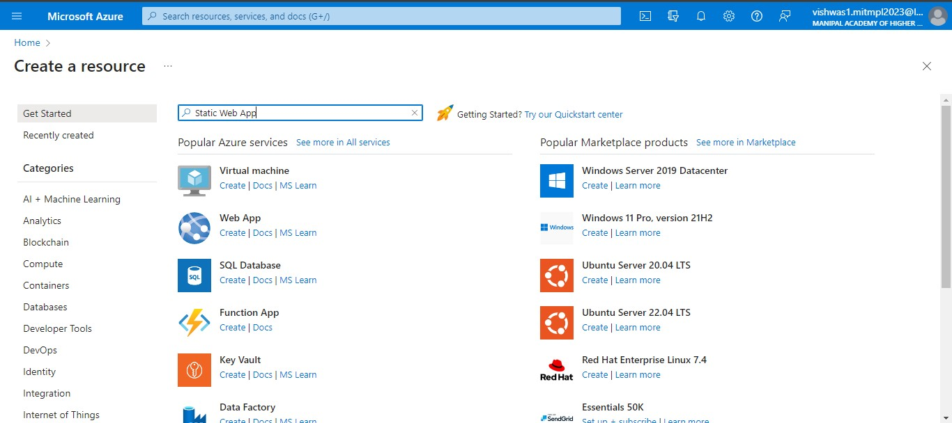

1. Select the “Static Web App” from the marketplace and click on “Create”

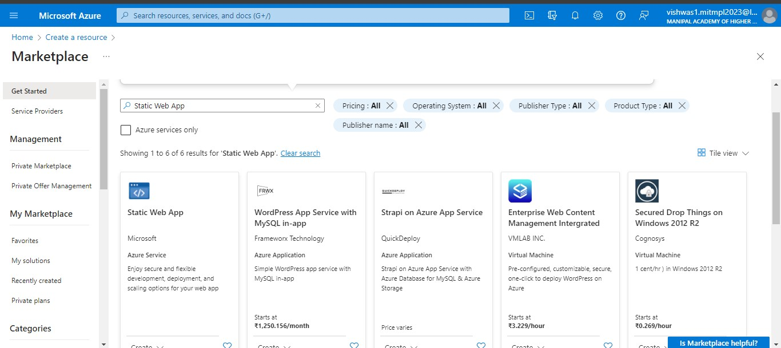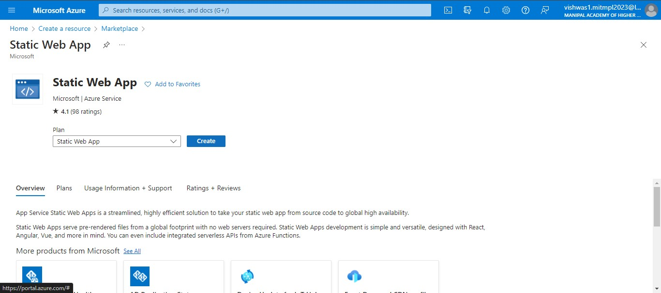

1. Enter the details which are marked as \* as given in the image

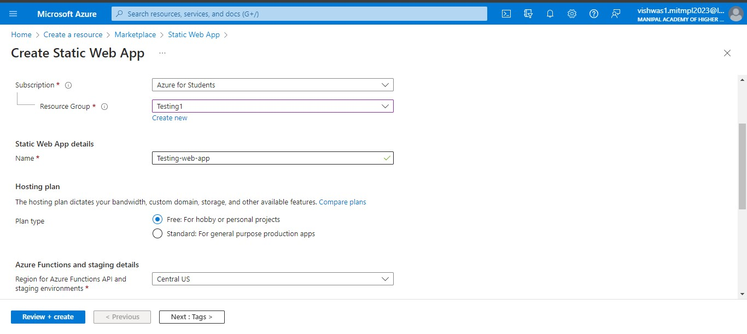

1. Select Source as “Github” and login to your github account or change your github account.

\* The account should contain a repository with the html code to host it in cloud.

Then select the Organization, Repository and Branch where the web page code is present

caascRohithRohith

1. Choose the build stack as HTML from the dropdowns.

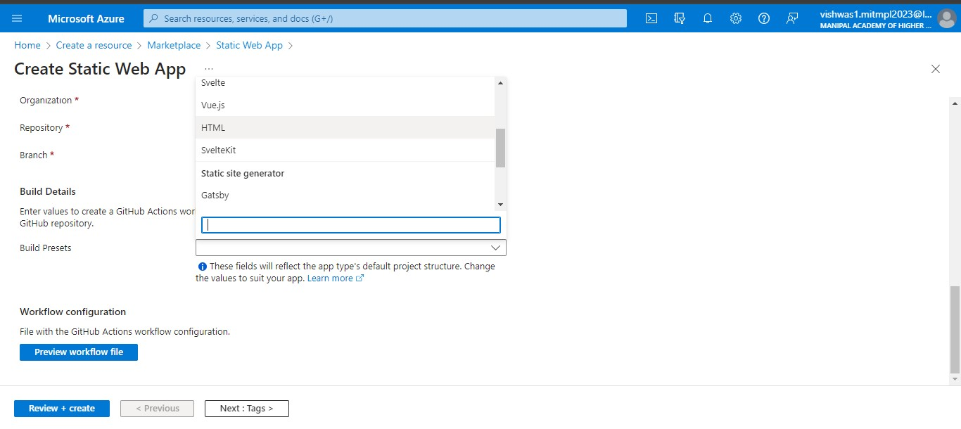

Leave everything as it is and click on “Review + Create”

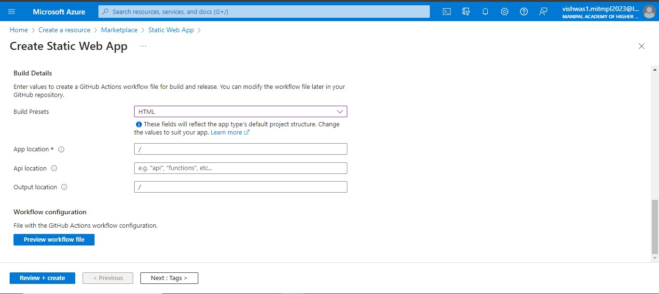

Click on “Create”

Click on

“

G

o to Resources

”

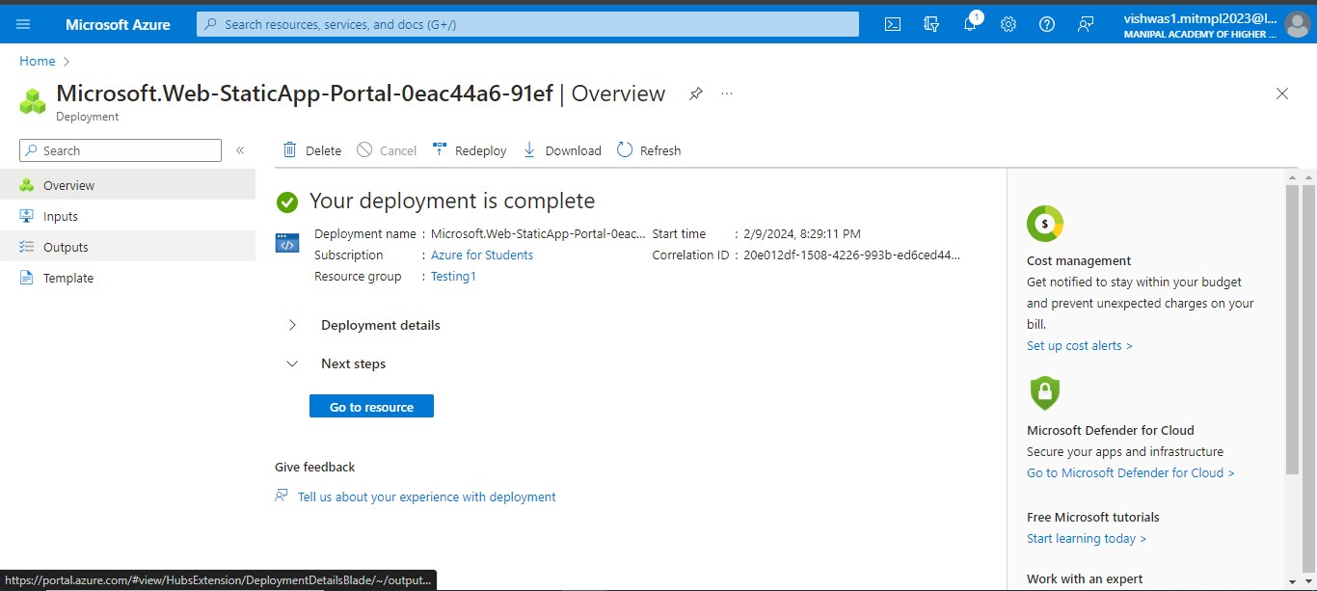

1. Now our web page is deploying, when it shows “Ready” in “View your application” tab click on “Visit Your Site”

It’ll open-up into new tab where we can see the web page hosted.

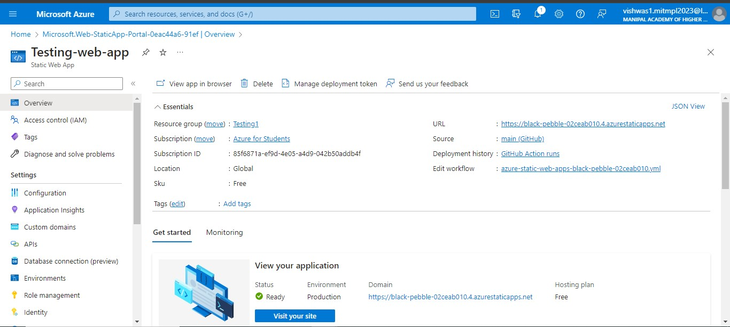

It is successfully hosted the static web app developed using HTML, CSS and JS

